**Practical Number 11:** Design Web Applications using Client-Side Session Management

## ****Steps to Implement Client-Side State Management****

* **View State**: Maintains data across post backs.
* **Query String**: Passes data in the URL.
* **Cookies**: Stores small data persistently.
* **Hidden Fields**: Stores temporary data in forms.

## ****1️ View State (ASP.NET Web Forms Only)****

Stores data in a hidden field but is accessible only on the same page.

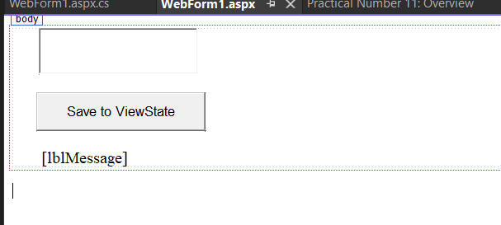

📌 **File:** WebForm1.aspx

<%@ Page Language="C#" AutoEventWireup="true" CodeBehind="WebForm1.aspx.cs" Inherits="Practical_Number_11.WebForm1" %>

<!DOCTYPE html>

<html>

<head>

<title>View State Example</title>

</head>

<body>

<form runat="server">

<asp:TextBox ID="txtName" runat="server" Height="50px" style="margin-left: 32px" Width="185px"></asp:TextBox>

<br />

<br />

<asp:Button ID="btnSubmit" runat="server" Text="Save to ViewState" OnClick="btnSubmit_Click" Height="47px" style="margin-left: 29px" Width="205px" />

<br />

<br />

&nbsp;&nbsp;&nbsp;&nbsp;&nbsp;&nbsp;

<asp:Label ID="lblMessage" runat="server"></asp:Label>

</form>

</body>

</html>

📌 **File:** WebForm1.aspx.cs

using System;

using System.Collections.Generic;

using System.Linq;

using System.Web;

using System.Web.UI;

using System.Web.UI.WebControls;

namespace Practical_Number_11

{

public partial class WebForm1 : System.Web.UI.Page

{

protected void Page_Load(object sender, EventArgs e)

{

if (ViewState["UserName"] != null)

{

lblMessage.Text = "Stored in View State: " + ViewState["UserName"].ToString();

}

}

protected void btnSubmit_Click(object sender, EventArgs e)

{

ViewState["UserName"] = txtName.Text;

lblMessage.Text = "Data Saved in View State!";

}

}

}

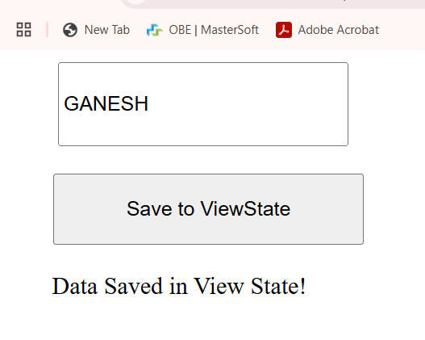

## ****2️ Query String (Passing Data in URL)****

Query strings pass data between pages using the URL.

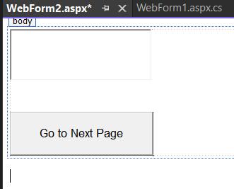

📌 **File:** WebForm2.aspx

<%@ Page Language="C#" AutoEventWireup="true" CodeBehind="WebForm2.aspx.cs" Inherits="Practical_Number_11.WebForm2" %>

<!DOCTYPE html>

<html>

<head>

<title>Query String Example</title>

</head>

<body>

<form runat="server">

<asp:TextBox ID="txtName" runat="server" Height="67px" Width="193px"></asp:TextBox>

<br />

<br />

<br />

<asp:Button ID="btnSubmit" runat="server" Text="Go to Next Page" OnClick="btnSubmit_Click" Height="62px" Width="203px" />

</form>

</body>

</html>

📌 **File:** WebForm2.aspx.cs

using System;

using System.Collections.Generic;

using System.Linq;

using System.Web;

using System.Web.UI;

using System.Web.UI.WebControls;

namespace Practical_Number_11

{

public partial class WebForm2 : System.Web.UI.Page

{

protected void Page_Load(object sender, EventArgs e)

{

}

protected void btnSubmit_Click(object sender, EventArgs e)

{

Response.Redirect("WebForm3.aspx?name=" + txtName.Text);

}

}

}

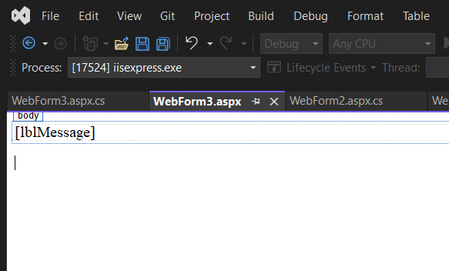

📌 **File:** WebForm3.aspx

<%@ Page Language="C#" AutoEventWireup="true" CodeBehind="WebForm3.aspx.cs" Inherits="Practical_Number_11.WebForm3" %>

<!DOCTYPE html>

<html>

<head>

<title>Query String Result</title>

</head>

<body>

<form runat="server">

<asp:Label ID="lblMessage" runat="server"></asp:Label>

</form>

</body>

</html>

📌 **File:** WebForm3.aspx.cs

using System;

using System.Collections.Generic;

using System.Linq;

using System.Web;

using System.Web.UI;

using System.Web.UI.WebControls;

namespace Practical_Number_11

{

public partial class WebForm3 : System.Web.UI.Page

{

protected void Page_Load(object sender, EventArgs e)

{

if (Request.QueryString["name"] != null)

{

lblMessage.Text = "Query String Value: " + Request.QueryString["name"];

}

}

}

}

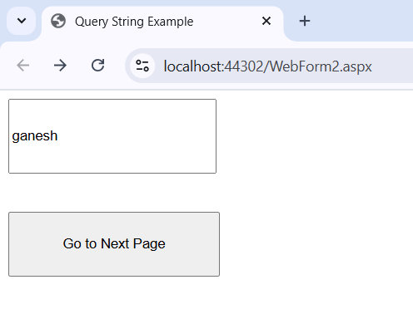

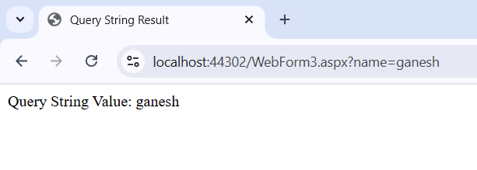

## ****3️ Cookies (Persistent Client-Side Storage)****

Stores small data on the client-side, accessible across pages.

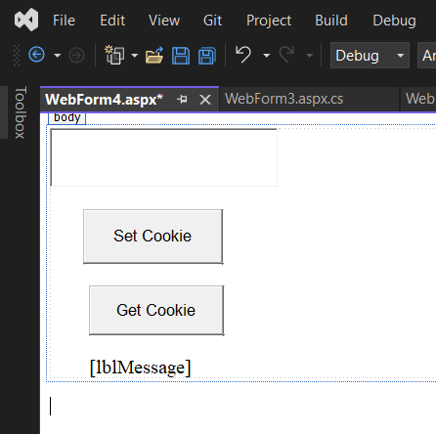

📌 **File:** WebForm4.aspx

<%@ Page Language="C#" AutoEventWireup="true" CodeBehind="WebForm4.aspx.cs" Inherits="Practical_Number_11.WebForm4" %>

<!DOCTYPE html>

<html>

<head>

<title>Cookies Example</title>

</head>

<body>

<form runat="server">

<asp:TextBox ID="txtName" runat="server" Height="55px" Width="226px"></asp:TextBox>

<br />

<br />

<asp:Button ID="btnSetCookie" runat="server" Text="Set Cookie" OnClick="btnSetCookie_Click" Height="56px" style="margin-left: 34px" Width="143px" />

<br />

<br />

<asp:Button ID="btnGetCookie" runat="server" Text="Get Cookie" OnClick="btnGetCookie_Click" Height="51px" style="margin-left: 40px" Width="138px" />

<br />

<br />

&nbsp;&nbsp;&nbsp;&nbsp;&nbsp;&nbsp;&nbsp;

<asp:Label ID="lblMessage" runat="server"></asp:Label>

</form>

</body>

</html>

📌 **File:** WebForm4.aspx.cs

using System;

using System.Collections.Generic;

using System.Linq;

using System.Web;

using System.Web.UI;

using System.Web.UI.WebControls;

namespace Practical_Number_11

{

public partial class WebForm4 : System.Web.UI.Page

{

protected void Page_Load(object sender, EventArgs e)

{

}

protected void btnSetCookie_Click(object sender, EventArgs e)

{

HttpCookie cookie = new HttpCookie("UserName", txtName.Text);

cookie.Expires = DateTime.Now.AddDays(7); // Cookie valid for 7 days

Response.Cookies.Add(cookie);

lblMessage.Text = "Cookie set successfully!";

}

protected void btnGetCookie_Click(object sender, EventArgs e)

{

HttpCookie cookie = Request.Cookies["UserName"];

if (cookie != null)

{

lblMessage.Text = "Stored Cookie Value: " + cookie.Value;

}

else

{

lblMessage.Text = "No Cookie Found!";

}

}

}

}

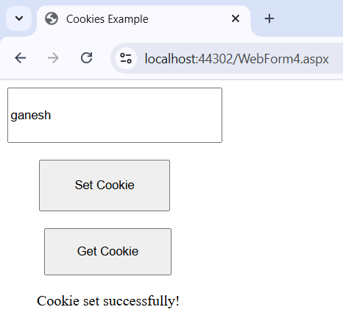

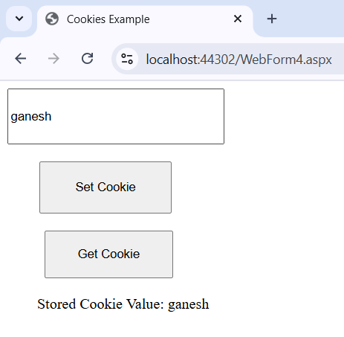

## ****4️ Hidden Fields (Storing Temporary Data)****

Stores data in an HTML form but remains invisible to the user.

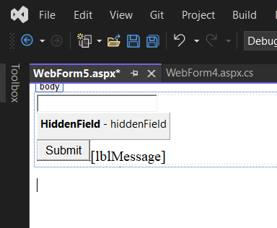

📌 **File:** WebForm5.aspx

<%@ Page Language="C#" AutoEventWireup="true" CodeBehind="WebForm5.aspx.cs" Inherits="Practical_Number_11.WebForm5" %>

<html>

<head>

<title>Hidden Field Example</title>

</head>

<body>

<form runat="server">

<asp:TextBox ID="txtName" runat="server"></asp:TextBox>

<asp:HiddenField ID="hiddenField" runat="server" Value="12345" />

<asp:Button ID="btnSubmit" runat="server" Text="Submit" OnClick="btnSubmit_Click" />

<asp:Label ID="lblMessage" runat="server"></asp:Label>

</form>

</body>

</html>

📌 **File:** WebForm5.aspx.cs

using System;

using System.Collections.Generic;

using System.Linq;

using System.Web;

using System.Web.UI;

using System.Web.UI.WebControls;

namespace Practical_Number_11

{

public partial class WebForm5 : System.Web.UI.Page

{

protected void Page_Load(object sender, EventArgs e)

{

}

protected void btnSubmit_Click(object sender, EventArgs e)

{

lblMessage.Text = "Entered Name: " + txtName.Text + ", Hidden ID: " + hiddenField.Value;

}

}

}

